**APPLICATION NAME**: Commute-Aid

**AUTHOR**:

Noelle Shierene V. Cervantes  
 Shella Mae B. Gutierrez  
 Gabriel Angelo A. Ngceen  
 Norrie B. Peñaverde

**1. Version History**

|  |  |  |  |
| --- | --- | --- | --- |
| **Author** | **Date** | **Version** | **Changes** |
|  |  |  |  |
|  | 07/3/18 | 1.0 | Initial Business Requirements Document |
|  |  |  | (BRD) creation |

**2. Overview Description**:

Commute-Aid is an application that helps improve the commuting process. It provides routes & which mode of transportation to take, alarms users when approaching their drop-off point, enables tracking of Public Utility Vehicles (PUVs), and allows users to reserve seats ahead of time. Also, it encourages public participation from other users - allowing them to rate, share experiences, and report problems on the route the users have taken.

**2.1 Scope-Purpose**

The scope of the project includes development and implementation of a mobile application that includes the following features:

* Route provider that suggests the optimal route to be taken for a trip specified by the user
* Different modes of transportation provider that includes an estimate time of arrival and fare estimate
* Alarm that serves as a notification when user approaches proximity to destination
* Route rater that enables users to rate the routes they have taken based on accuracy, comfortability, and availability

**2.2 Background**

Commuting has been an essential part of every person’s daily routine. Whether it may be traveling to a workplace, school, mall, or elsewhere, commuting is ineluctably an integral element in our diurnal tasks. However, due to a significantly increasing number of commuters combined with the troublesome process commuters have to endure every day, those traveling across Metro Manila have been proven to be the most dissatisfied in Asia Pacific region. (The Manila Times, 2016) The problems contributing to the disgruntlement of those dependent upon certain means of transportation the government offers include heavy traffic primarily caused by the sheer number of vehicles as well as the deficiency in major roads, the long waiting lines during rush hours before getting a ride, and the unreliability of transportation vehicles. The challenges aforementioned make it necessary for all means that may contribute to the improvement of the current commuting process across the Metro. Hence, the development of a commuting application that aims to address these problems so as to provide ease and comfort for the commuters.

**2.3 Objectives**

The objectives of this project are defined to serve as a guideline to determine success of the project. These objectives must be met in order to ensure that the features and functionalities agreed upon are successfully delivered by the end of project development.

**2.3.1 General Objectives**

The general objectives of the project are to create a fully-functional commuting application that is free of errors as well as to deliver the features and functionalities included in the scope of the project. The specific objectives are the following:

**2.3.2 Specific Objectives**

* To create an application that provides optimal route and different modes of transportation for the users
* To provide reliable time and fare estimates with high accuracy to each route suggested by the application
* To enable notification to users through alarm activation that is geo-based or time-based when users are approaching proximity to drop-off point
* To enable provision of reviews from users regarding the route they have taken
* To help improve the commuting process by at least 50%
* To ameliorate commuter’s dread of the commuting process in Metro Manila through providing ease to commuters by at least 40%
  1. **Impacted User activities**
* Users can view a wide variety of possible routes to a specified destination
* Users can keep track of the current location of PUVs
* Users can reserve seats to their desired modes of transportation (except for railway transits)
* Users can rate routes they have taken
* Users will be notified through a mobile phone alarm signaling they are approaching proximity to their drop-off

**2.5 Business Requirements**

**2.5.1 Viewing of Possible Routes**

* Suggestion of optimal routes to be taken
* Provision of a wide variety of modes of transportation for a specific trip
* Viewing of route rates based from reviews of other users, estimated time of arrival, as well as the estimated fare for the trip

**2.5.2 Tracking of Location of PUVs**

* Creation of a different version of the mobile application specifically for drivers
* Tracking of current location of their chosen mode of transportation

**2.5.3 Reservation of Seats**

* Booking of seats of the user’s preferred modes of transportation
* Viewing of available seats

**2.5.4 Rating of Routes**

* Enabling of community-based interaction through reviews provided by users
* Allowing of users to rate their experience following the suggested route given by the application

**2.5.5 Automation of an Alarm**

* Geo-based activation of alarm when users are approaching their destination
* Time-based activation of alarm when the ETA provided by the application elapses

**2.6 Use Case/User Stories**

**Use Case #1**

**Scenario: Viewing and selecting a route to take**

Primary Actor: User/Commuter

**Preconditions:**

* + The user has downloaded the mobile application
  + The user has his/her mobile device's location access turned on.
  + The user has internet connection.

**Postconditions:**

* + The user has selected a route for his trip
  + The user has been informed of what mode of transportation to take and an estimation of how much the fare costs.

**Basic Flow:**

* 1. The user chooses the starting point from the map (either his/her current location or chooses a location specifically)
  2. The user chooses for his/her desired destination.
  3. The application loads then displays a list of possible routes, along with what modes of transportation to take, and an estimation of how much the fare costs.
  4. The user selects a route from the list of routes given by the application.

**Alternative Flows:**

* 1. The user chooses the starting point from the map (either his/her current location or chooses a location specifically)
  2. The user chooses for his/her desired destination.
  3. The application loads then displays a list of possible routes, along with what modes of transportation to take, and an estimation of how much the fare costs.
  4. The user looks at the ratings of the routes to see which one is better.
  5. The user selects the best route to his/her liking.

**Use Case #2**

**Scenario: Finding PUVs to ride**

Primary Actor: User/Commuter

Stakeholders and Interest: PUV Drivers

**Preconditions:**

* + PUV drivers are logged in to the application via smartphone
  + PUV drivers' mobile device have consistent internet connection
  + PUV drivers' mobile device's location access is turned on
  + The commuter has selected a route to take (see user story #1)

**Postconditions:**

* + The commuter's trip has started

**Basic Flow:**

* 1. User has selected a route to take
  2. The application locates the vehicles according to what mode of transportation the user needs to take.
     1. Ex. If the user's route declares he/she needs to take a bus, the app will find available buses on the map.
  3. When the user finds an available vehicle and has ridden it, the application detects that the trip has started.

**Use Case #3**

**Scenario: Reservation of PUV seats**

Primary Actor: User/Commuter

Stakeholders and Interest: PUV Drivers

**Preconditions:**

* + The user has downloaded the app or has access to the web version
  + PUV drivers have downloaded the app
  + PUV drivers' mobile device have consistent internet connection

**Postconditions:**

* + The PUV driver's vehicle seats will be booked by commuters using the application
  + The driver will be informed of how many reservations his vehicle has for his next trip

**Basic Flow:**

* 1. After selecting a route to take for his/her trip, the user selects to book a ride in a PUV in advance.
  2. The application loads and displays the available PUVs (suited to his/her trip) and their details such as:
     1. Vehicle pick-up location
     2. Time of departure
     3. Available seats remaining
  3. The user decides on which vehicle to reserve a seat in, for an additional cost.

**Use Case #4**

**Scenario: Rating of Routes**

Primary Actor: User/Commuter

Stakeholders and Interest: Other commuters

**Preconditions:**

* + The user's trip has been completed

**Postconditions:**

* + The application adds the review to the route's overall rating, reflected in real time

**Basic Flow:**

* 1. When the user has finished a trip through his/her selected route, the application gives the option to rate the route.
  2. The user accepts the prompt and gives his/her honest rating scores
  3. The application prompts the user to give a short statement on his/her overall experience
  4. The user provides the short statement and submits the result to the application's database.

**Use Case #5**

**Scenario: Automation of an Alarm**

Primary Actor: User

**Preconditions:**

* + The user has decided what route to take for his/her trip

**Postconditions:**

* + The application gives a notification via an alarm on the user's mobile device

**Basic Flow:**

* 1. Before the user's trip begins, he/she will be given the option to enable an alarm to notify the user when he/she is nearing his/her drop-off point
  2. The user turns on his/her mobile device's location access
  3. The application tracks the user's location throughout the trip
  4. When the user is nearing his/her drop-off point, the user will be notified that he/she will need to get off the vehicle soon.

**Alternate Flow:**

* 1. If the device's location access is faulty or was not enabled, the application will set the alarm based from the route's ETA to the user's destination
  2. When the route's ETA has elapsed, the application notifies the user that he/she has either arrived at his/her destination or is very near.

**2.7 Use Case Diagram**

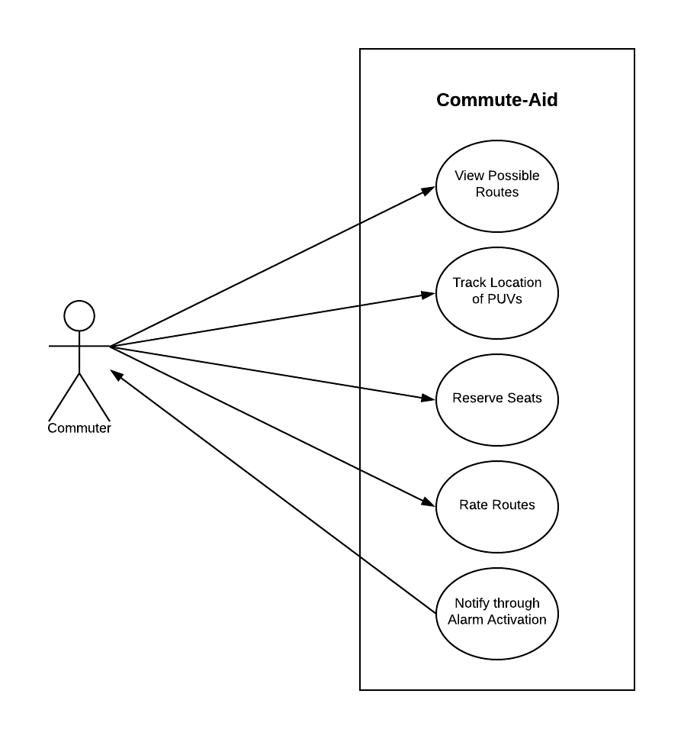

**2.8 Wireframes**

